10th Antwerp Open Backgammon Tournament

8 & 9 September 2012
Organised by the
Antwerp Backgammon Club vzw

Location: Café den Bengel Grote Markt 5 2000 Antwerpen

INFO
www.backgammon.be

Or call for information Paul Baeyens : +32(0)475.256.734

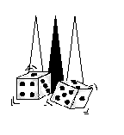

Website & E-mail Antwerp Backgammon Club | http://www.backgammon.be
Info city Antwerp & hotels | http://www.visitantwerpen.be
Information: Baeyens Paul | 00.32.(0)475.256.734

